|  |  |
| --- | --- |
|  | **Department of Computer Science**  **University of Management and Technology** |

**Assignment Description File**

|  |  |
| --- | --- |
| Course Name: | **Software Engineering (CC2101/CC281)** |
| Section: | V-14 |
| Teacher: | **Rida Ayesha** |
| Student Name & ID: | **Aadam Hashmi (F20232661025)**  **Sahra Parvaiz (F20232661050)** |
| Assignment No.: | **06** |
| Deadline: | **Late submissions are not Accepted**  Follow LMS submission deadline |

**NOTE: PLAGIARIZED ASSIGNMENT EITHER FROM CLASSMATES OR INTERNET WILL BE MARKED STRAIGHT ZERO. NO ASSIGNMENT WILL BE ACCEPTED AFTER DEADLINE. ALWAYS MENTION SECTION ON YOUR ASSIGNMENT OTHERWISE MARKS WILL BE DEDUCTED. USE THE SAME TITLE PAGE AS ASSIGNMENT DESCRIPTION**

**USE THIS FORMAT TO SUBMIT YOUR SOLUTIONS.**

**Assignment Description:**

**Q1:** Create a major **Work Breakdown Structure (WBS)** of your projectonan online tool, **Project Manager** along with the assignment of **dates**, **duration, dependencies** and **human** **resources**.  
Show the **critical path.**

**Q2:** Create **Mockup screens/prototype** on an online tool, **Figma** for any **05 main Use Cases** of your project.

**Submission Guidelines:**

1. Make a MS Word file. Share the **figma link** of your **project** in your assignment file.
2. Use an **online** tool **“Project** **Manager”** for **Project WBS & Scheduling.**

**Online Tool Link:**

<https://www.projectmanager.com/>

1. Use an **online** tool “**Figma”** to create **Mockup screens/prototypes**.

**Online Tool Link:**

<https://www.figma.com/>

1. Submit **Soft** **Copy** on LMS.

**Note: See the uploaded video tutorial (for above tools) on LMS for reference.**

**SEE THE TEMPLATE ATTACHED BELOW**

# Project Scheduling & Prototyping

## 8.1 Work Breakdown Structure (WBS)

## 

## 8.2 Gantt-Chart for Work Breakdown Structure (WBS)

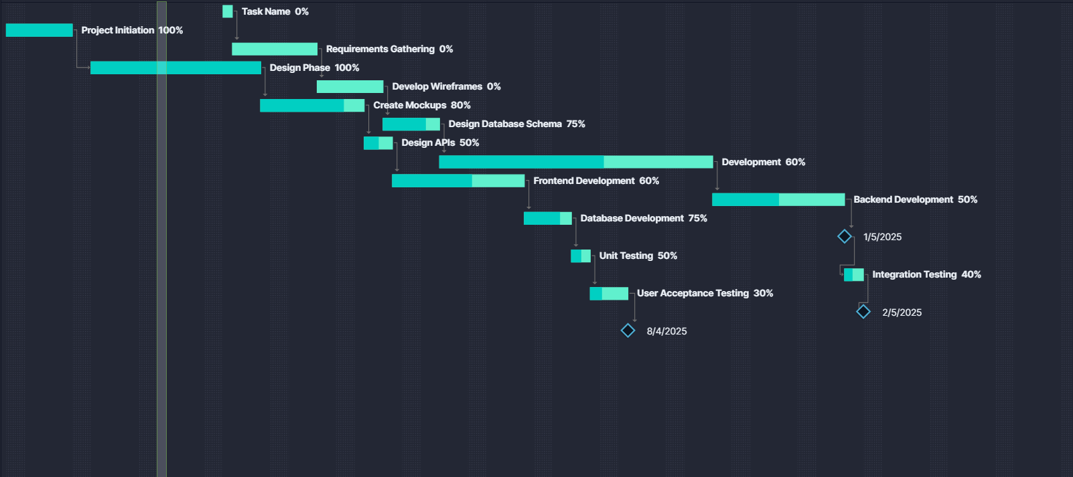

## 8.3 Critical Path:

## 

## 8.4 User interfaces (Prototypes/mock screens)

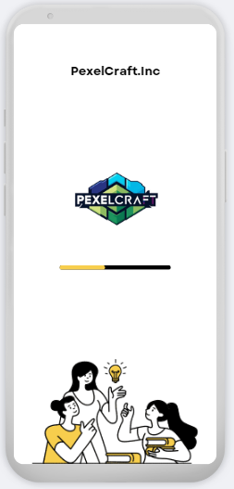

**Prototype 1: Splash Screen,**

**this screen comes when user starts the application from scratch**

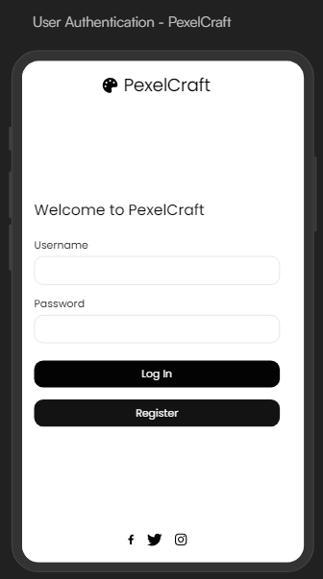

**Prototype 2: Sign in Screen**

**this screen can open after you sign up or login to see your projects**

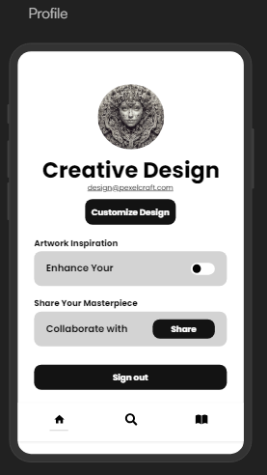

**Prototype 3: profile tab**

**This screen is the main screen where yu can search for images**

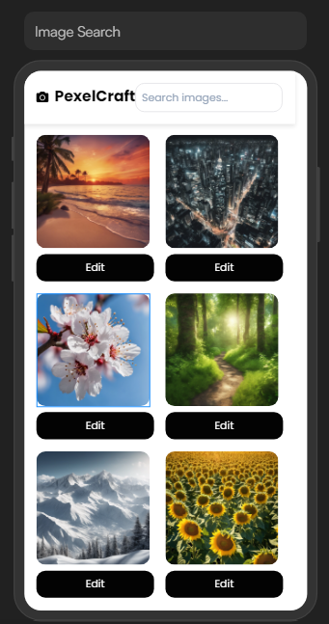

**Prototype 4: main screen**

**it’s one of the important sections of application, this is the editing interface**

This is the editing interface of the app

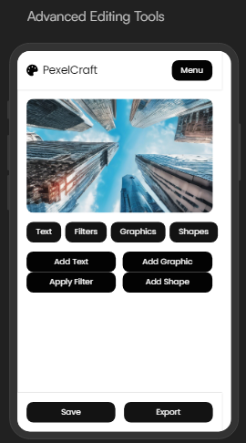

**Prototype 5:**

**Editing interrface**